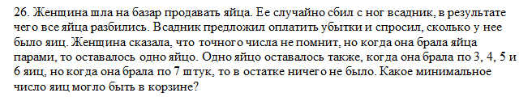

#include <iostream>

#include <clocale>

#include <cmath>

using namespace std;

int main()

{

int min = 1000;

setlocale(LC_ALL, "Russian");

for (int i = 1; i <= 1000; i++)

if (i % 2 == 1 && i % 3 == 1 && i % 4 == 1 && i % 5 == 1 && i % 6 == 1 && i % 7 == 0)

if (min > i)

min = i;

cout << min << endl;

system("pause");

return 0;

}

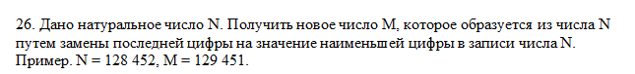

#include <iostream>

using namespace std;

int main() {

int n, m, min = 10;

cin >> n;

m = (n / 10) * 10;

do {

if (n % 10 < min)

min = n % 10;

n /= 10;

} while (n > 0);

m += min;

cout << m;

}



#include <iostream>

using namespace std;

int reverse_number(int number)

{

int n = 0;

while (number)

{

n = 10 * n + number % 10;

number /= 10;

}

return n;

}

int main()

{

setlocale(0, "rus");

cout << "Введите число ";

int number;

cin >> number;

if (number == reverse_number(number))

cout << number << " Это палиндром" << endl;

else

cout << "Это не палиндром " << endl;

system("Pause");

return 0;

}